1. **Problem Statement:**

• Draws a circle using Bresenham’s Circle Drawing Algorithm cantered in the window.

• Uses the Flood Fill algorithm to fill the circle and an area outside the circle with different colors.

• Draws a rectangular boundary around the area.

1. **Overview:**The code performs the following actions:

* Initializes the graphics window.
* Draws a rectangle centered in the screen as a bounding area.
* Draws a circle centered using Bresenham’s circle drawing algorithm.
* Fills:
* The circle’s interior with red.
* The area outside the circle (but inside the rectangle) with green.

1. **Algorithm:  
   a. Bresenham’s Circle Drawing Algorithm:**

A midpoint algorithm is used to draw a circle using integer arithmetic. It avoids floating-point calculations and is highly efficient for raster devices.

**void bresenham(int x, int r, int c, int d)  
•** x is the starting x-coordinate (0).

• r is the radius.

• c and d are the circle’s center coordinates.

• Symmetry is used to plot 8 points per iteration.

**b. Flood Fill Algorithm (4-directional):**

A recursive region-filling algorithm. It fills a region with a given color, starting from a point, and spreads to all connected pixels of the same original color.

**void FloodFill(int x, int y, int original, int fill_clr)**

* It checks the current pixel color.
* If the color matches original, it sets it to fill_clr.
* Then recursively calls the function in four directions (left, right, up, down).

1. **Code:**

|  |  |
| --- | --- |
| #include <graphics.h>  #include <math.h>  #include <stdio.h>  #include <bits/stdc++.h>  #include <conio.h>  #include <windows.h>  using namespace std;  void FloodFill(int x, int y, int original,int fill_clr)  {  int clr = getpixel(x,y);  if(clr==original)  {  putpixel(x,y,fill_clr);  FloodFill(x+1,y,original,fill_clr);  FloodFill(x-1,y,original,fill_clr);  FloodFill(x,y+1,original,fill_clr);  FloodFill(x,y-1,original,fill_clr);  }  }  void bresenham(int x,int r,int c,int d)  {  int y,p;  p=3-2*r;  y=r;  while( x<=y)  {  putpixel(x+c,-y+d,RED);  putpixel(x+c,d+y,RED);  putpixel(-x+c,d+y,RED);  putpixel(-x+c,d-y,RED);  putpixel(y+c,d+x,RED);  putpixel(y+c,d-x,RED);  putpixel(-y+c,d+x,RED);  putpixel(-y+c,d-x,RED);  if(p>=0)  {  p=p+4*(x-y)+10;  x=x+1;  y=y-1;  } | else  {  p=p+4*x+6;  x=x+1;  }  }  }  int main()  {  int gd = DETECT, gm;  initgraph(&gd, &gm, "");  int r=50;  float th=0;  int A = getmaxx();  int B = getmaxy();  int c,d,x,y,original,fill_clr;  setcolor(10);  line(-200+A/2,-100+B/2,200+A/2,-100+B/2);  line(200+A/2,-100+B/2,200+A/2,100+B/2);  line(200+A/2,100+B/2,-200+A/2,100+B/2);  line(-200+A/2,-100+B/2,-200+A/2,100+B/2);  bresenham(0,50,A/2,B/2);  FloodFill(A/2, B/2,BLACK,RED);  FloodFill(A/2+51,B/2+51,BLACK,GREEN);  getch();  closegraph();  return 0;  } |

1. **Output:**

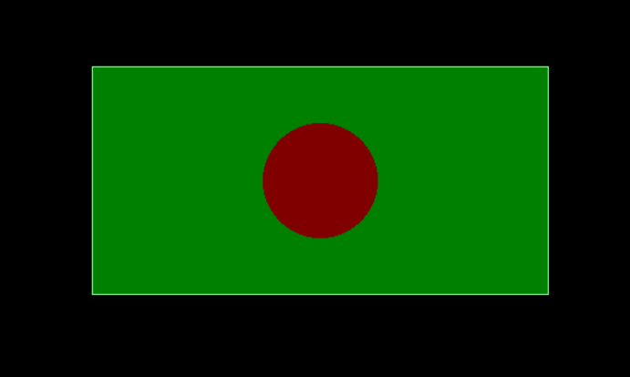

1. **Discussion:**

• Simple demonstration of **midpoint circle drawing** without relying on high-level libraries.

• Recursive **flood fill** shows region filling.

• Clean separation between drawing and filling logic.

• Uses symmetry in circle drawing to minimize computation.